A-Mazing Maze Game

Game Design Documentation

Rainbow Aura Co

Contents

Pitch 4

Game Overview 4

Brief Overview 4

Genres 4

Platform 4

Target Market 4

Emotional Rewards 5

Story/Game Progression 6

Plot 6

Levels 6

Progression 6

Art/Design (Mood board) 7

Concept 7

Character 7

Environment Idea 7

Environment Art 8

GUI 10

Sound & Music 11

Mechanics & Gameplay 11

Sound Engineering 11

Mechanics 12

Code 12

Pseudo-code 13

Example Code 13

Physics 13

Prototype & Testing 14

Prototype 14

Alpha 14

Beta 14

Estimated Schedule 14

Week 1: 14

Week 2: 14

Week 3: 14

Week 4: 14

Week 5: 14

Week 6: 14

Week 7: 15

Week 8: 15

Week 9: 15

Schedule Table 15

Resources Needed 15

Hardware 15

Software 15

People needed. 15

Time needed. 15

Similar Titles 16

Game 1: Zardy’s Maze 16

Game 2: Six inches under 16

Game 3: Maze 16

Pitch

Hi, I’m Richard Pountney.

Have you ever had the feeling of curiosity to explore a big maze? Have you been able to satisfy that curiosity?

Well, my game can satisfy that curiosity.

My game is for curious explorer-type people of most ages.

At my game’s core, it is about discovery & exploration with a tad bit of puzzle-solving.

This first-person game is placed in an eerie abandoned theme park setting & once you enter the maze you will realize that it is amazingly bigger than what you would’ve thought.

The maze goes from wooden fencing to stone walls to metal wire fencing and then to plants like hedges that creepily don’t seem to be overgrown. The plant area is meant to represent the final area.

Game Overview

Brief Overview

The game is going to be a maze runner-type game, so you are supposed to find your way out of the maze & find some items to help you with escaping.

Genres

Maze, Puzzle, Adventure, Escape the Room

Platform

Windows & Mac

Target Market

* It is for people who like to solve mazes from the first-person perspective.
* It is for people who like to explore & discover things & like the eerie atmosphere around them while they explore.
* I want people to feel accomplished from playing the game.
* I want people to feel frustration & excitement while playing the game.

Emotional Rewards

|  |  |  |
| --- | --- | --- |
| Emotional Rewards | Rating: 1 to 10 | Reason |
| Accomplishment | 7 | This is high because you would have figured out how to do something & just felt accomplished for that. |
| Collection | 3 | This is low because there is barely anything to collect throughout the game. |
| Competition | 1 | This is low because it is barely competitive unless it gets popular with speedrunners. |
| Connection | 2 | This is low because it barely gives you a way to connect with others through the game but if it gets popular with a speedrunning community then that would be your connection. |
| Creation | 1 | This is low because you are barely creating anything in the game. |
| Discovery | 9 | This is very high because this is the core emotional reward that I want the players to get. + the use of the player’s curiosity. |
| Empathy | 4 | This is in the middle because I want the player to have empathy for themselves. |
| Empowerment | 5 | This is in the middle because I do want the player to empowered but it isn’t my main priority. |
| Escapism | 5 | This is in the middle because I don’t know how much the player would be emersed in the game, but it doesn’t mean that it isn’t possible for the player to feel this while playing. |
| Excitement | 7 | This is high because it can be exciting to be able to explore & to have the ability to satisfy their curiosity. |
| Fear | 3 | This is low because I don’t want the player’s main emotion to be fear of being followed but I would still have some eerie sounds in the background. |
| Frustration | 7 | This is high because this feeling would occur from the player being annoyed at themself for some reason or for the reason of something being so obvious. |
| Growth | 2 | This is low because it isn’t a high priority. |
| Joy | 4 | This is in the middle because it is similar to the excitement but still a different feeling & you would only get some joy throughout the game. |
| Mastery | 6 | This is in the middle because you would be able to master the skill to see when to use a certain item. |
| Reflection | 5 | This is in the middle because the player may want to reflect on how the game played & how well they got through. |
| Relaxation | 2 | This is low because the eerie sounds may make the player not be able to relax but some people may be able to relax even with the eerie sounds. |
| Reward | 4 | This is in the middle because there won’t really be any rewards in the game but there may only be a few achievements at the minimum. |

Story/Game Progression

This game is to encourage exploration.

Plot

You go to an a-mazing park but when you enter, the entrance disappears so you have to find your way out but find that you may need to get the item to help you get through.

Levels

The plan is for each type of wall/fence to mean a new area, but you can backtrack to the prior area if there is something you missed there.

* The known areas at this point are:
  + a wooden fencing area (possibly having a few types of wooden fencing which are different areas)
    - The item for this area would be something to break some wood (possibly an axe)
  + a stone wall area (possibly having a few types of stone walls which are different areas)
    - The item for this area would be something to break some stone (possibly a pickaxe or sledgehammer)
  + metal fencing area
    - The item for this area would be something to cut metal wire (some wire cutters)
  + plant walls area (Bush/hedge)
    - The item for this area would be something to cut some bush/hedge (possibly a blade of some kind)

I want to encourage exploration.

Progression

Art/Design (Mood board)

Concept

Environment: An old/abandoned theme/amusement park environment.

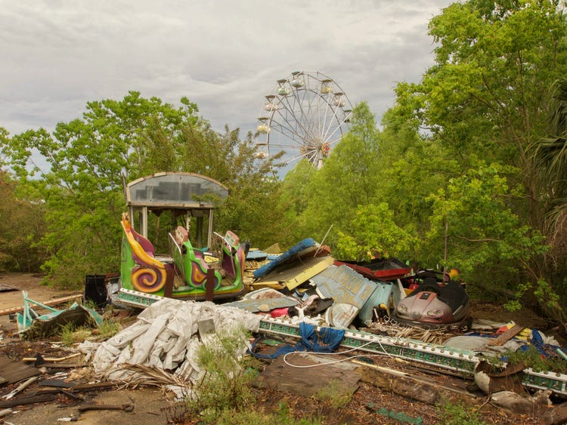

<https://www.insider.com/abandoned-amusement-parks-2018-2#once-the-largest-theme-park-in-central-kansas-the-joyland-amusement-park-was-home-to-one-of-the-last-surviving-original-wooden-coasters-12>

The maze walls are stone, wood, metal &or plants(bush) (it is multiple because I want a different wall type to represent different parts of the maze & possibly how far you are in the maze).

The maze is mysterious because it seems bigger than what it looked like on the outside.

The look & feel of the game will have an eerie feel to it as well as encourage curiosity.

Character

* You don’t really get to see the player character.
* The player character is supposed to represent the player, so I don’t really want to make the player see their character except for a minimum of their hands and maximum of their forearms so there can be some emersion.
* At this point, there will be no enemies.

Environment Idea

* Possibly an old theme park environment. (can’t really provide images because I can’t find ones that I like so I most probably will make my own)
* The maze walls are stone walls, wood fencing, metal fencing (wire fencing), and plant bush(hedges). I have chosen this because I want it to be a mix of environmental feelings.
* In a way, it is like the backrooms, but I don’t want it to be like that as much as I can at least.

Environment Art

* Some of the textures here <https://github.com/Stampard0/Textures> (mainly what is in the Fence & Walls for Maze file and the Terrain file).
* Here are some examples

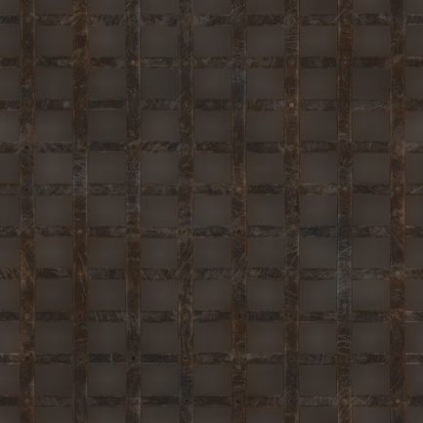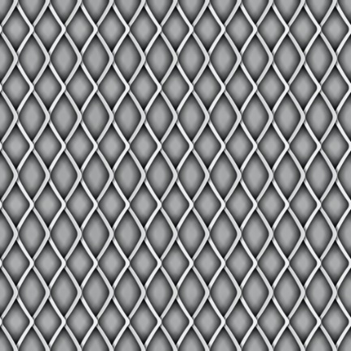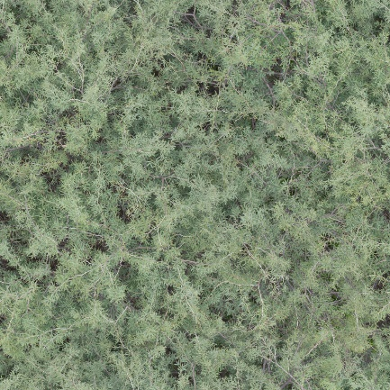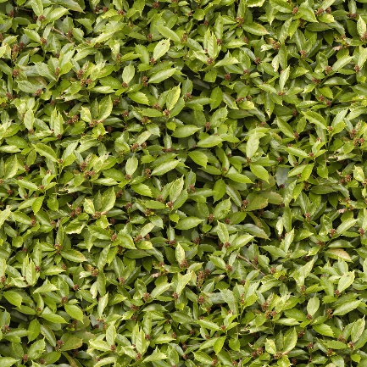

all of these are downloaded from <https://www.textures.com/library>

GUI

Planning on the photo being a little look of the maze but not showing the maze path. Possibly a panorama (camera is turning around) & possibly have the name of the game somewhere (maybe moving to a different spot depending on what photo)

Loading Bar

* Splash screens
* Main Menu

Exit/Close

Options

Continue]

Start/New_Game

Looking over the amusement part, looking at the amusement park or looking at the entrance to the maze

Selecting the Start/New_Game or Continue button the camera moves into the entrance of the maze. (With a little spin)

For the Start/New_Game button if you already have a save then it will ask if you want to over right your previse save. If you do, then it will move the camera into the entrance & if you don’t then it won’t do that.

For the Continue button, it will move the camera into the entrance with a bit of a faster spin.

* HUD

Hotbar

It is a very simple HUD

Sound & Music

* There will be footstep sounds that play when the player character moves.
* There will be sounds for when the player character jumps.
* There will be sounds for when the player uses items & picks up items.
* The game would need some subtle eerie sounds. (Like some footstep sounds (that aren’t the players) & some generic eerie sounds.)
* There will be a basic lowkey tune that plays while on the main menu.
* I will use the audio to enhance the feeling of uncertainty.

Mechanics & Gameplay

Sound Engineering

* All the sounds are planned to be 3dimensional & have a depth of field effect.
* There would be footstep sounds from the player character when they walk.
  + It would be implemented by making it play each time the player character steps.
* There would be a jump & landing sound that plays when the player character jumps.
  + The jump sound would be implemented by making it play when the player presses the jump button.
  + The landing sound would be implemented by making it play when the player character lands on a solid platform/the ground.
* There would be sounds for each item when they are picked up & used.
  + The pickup sound will be the same for each item & it would be implemented by making it play when the player presses the interact button on the item.
  + The use sound will be a different sound for each item but are implemented the same way which is when the player presses the use item button on an interactable wall/fence it will play the use item sound.
* There would be an eerie(s) sound that plays randomly & at a random depth of field each time.
  + It would be implemented by making it trigger at certain areas &or on a random timer controller program.

Mechanics

|  |  |  |  |
| --- | --- | --- | --- |
| Mechanic | Use (if explanation needed) | Trigger/Control (if needed) | Controller Trigger |
| Jump |  | Space bar | Xbox A button  PlayStation X button  Switch B button  (The controller’s bottom face button) |
| Movement |  | W, A, S, D, or arrow keys | All controller’s left joystick |
| Crouch |  | Left Shift key | Xbox B button  PlayStation O button  Switch A button  (The controller’s right-most face button) |
| Inventory/  Hotbar | Your storage for items you find. To tell what item you are currently holding to will be highlighted & you would see it in the character’s hand(s). | The mouse scroll wheel & number keys (Not the num pad) to change what you are holding | All controller’s bumper buttons |
| Use item | Use the current item that is in your hand | Left mouse click &or Q key | Either all controllers right trigger or  Xbox Y button  PlayStation r button  Switch X button  (The controller’s top face button) |
| Interact | Use to interact with an interactable | Right mouse click &or E key | Either all controller’s left trigger or  Xbox X button  PlayStation o button  Switch Y button  (The controller’s left-most face button) |
| Camera Control |  | Mouse movement | All controller’s right joystick |

Code

* The game will need:
  + Code to implement the movement controls (counting the jump & crouch controls).
  + Code to implement the interaction & use item controls.
  + Code to implement the Inventory/Hotbar.
  + Code to implement camera controls.

Pseudo-code

* Movement:
  + Pressing the W, up arrow key, or moving the controller left joystick up makes the player character moves forward.
  + Pressing the A, left arrow key, or moving the controller left joystick left makes the player character moves left.
  + Pressing the S, down arrow key, or moving the controller left joystick down makes the player character moves backward.
  + Pressing the D, right arrow key, or moving the controller left joystick right makes the player character moves right.
* Camera Control:
  + Moving the mouse or moving the controller right joystick moves the direction the camera is looking.
* Jump:
  + Pressing the space bar or the controller’s bottom face button makes the player character jump.
* Crouch:
  + Pressing the left shift key or the controller’s right-most face button toggles the crouch action.
* Interact:
  + Pressing the right mouse click, the E key, the controller’s left trigger, or the controller’s left-most face button. This will only work if something is glowing yellow to mean it is interactable. Pressing the interact button on an interactable will make you pick it up if it is an item but if it is a piece of paper or a sign then it will trigger a text box.
* Inventory/Hotbar:
  + The currently held item will be shown as a different colour & will be shown in the character’s hand(s). The hotbar will only show when the player has an item & it will show only the item that the player has. It will also show the number key that you can press to select the item without needing to scroll through your whole hotbar.
* Use item:
  + Pressing the left mouse click, Q key, controller’s right trigger, or the controller’s top face button. By pressing the use button, you will use the current item that is highlighted in your hotbar.

Example Code

* For movement
* For Interaction

Physics

* It will need the rigid body physics for at least the gravity physics.
* By applying the rigid body component to the player character.

Prototype & Testing

Prototype

It would be very minimalistic in design, but it would have most of the controls & mechanics.

Alpha

It would have at least some of the maze layouts done & have textures for the walls of the current maze layouts. It would also have some of the item’s models (the items that can be used for the current maze layouts that are in the game).

Beta

It would have almost all the maze layouts done & have all the wall textures in the game ready for use. It would also have most if not all of the models for the items & have all the items in the game.

The way that the game would be tested is by starting the game at the point that I want to test (like if I need to test physics, an item pickup, or testing an item use).

Estimated Schedule

Week 1:

* Made a map out of the first area (where the item will be & where you start)
* Made the model of the first item (The axe)
* Made movement controls for player (controller support & keyboard & mouse)
* Made a test map/scene for testing

Week 2:

* Made a map out of the second area (where the item will be & the connection to the first area)
* Made the model of the second item (The pickaxe or sledgehammer)
* Started making the first area of the maze from the map out

Week 3:

* Made a map out of the third area (where the item will be & the connection to the second area)
* Made the model of the third item (The wire cutters)
* Finished making the first area of the maze from the map out

Week 4:

* Made a map out of the fourth area (where the item will be, the connection to the third area & the endpoint)
* Made the model of the fourth item (A blade)
* Started making the second area of the maze from the map out

Week 5:

* Finished making the second area of the maze from the map out
* Imported items into the game
* Made item interaction controls & hotbar/inventory (controller, keyboard & mouse)

Week 6:

* Made special wall objects to have special interactions with specific items
* Started making the third area of the maze from the map out

Week 7:

* Finished making the third area of the maze from the map out
* Started & finished making the fourth area of the maze from the map out
* Implemented all the connection points to be the special wall objects

Week 8:

* Made a Start menu & ending scene
* Implemented sound
* Bug fixes
* Private beta

Week 9:

* Release the game

Schedule Table

|  |  |  |  |  |  |  |  |  |  |  |
| --- | --- | --- | --- | --- | --- | --- | --- | --- | --- | --- |
| Task | Week 1 | Week 2 | Week 3 | Week 4 | Week 5 | Week 6 | Week 7 | Week 8 | Week 9 | Week 10 |
| GDD |  |  |  |  |  |  |  |  |  |  |
| Overview |  |  |  |  |  |  |  |  |  |  |
| Story |  |  |  |  |  |  |  |  |  |  |
| Concept Art/Mood Board |  |  |  |  |  |  |  |  |  |  |
| Mechanics |  |  |  |  |  |  |  |  |  |  |
| Assets (Items) |  |  |  |  |  |  |  |  |  |  |
| Assets (Map) |  |  |  |  |  |  |  |  |  |  |
| Code/Scripts |  |  |  |  |  |  |  |  |  |  |
| GUI |  |  |  |  |  |  |  |  |  |  |
| Testing |  |  |  |  |  |  |  |  |  |  |
| Prototype |  |  |  |  |  |  |  |  |  |  |
| Alpha |  |  |  |  |  |  |  |  |  |  |
| Beta |  |  |  |  |  |  |  |  |  |  |

Resources Needed

Hardware

* A PC &or Laptop
* Controllers (Xbox, PlayStation, Nintendo Pro controller, & Steam Controller)

Software

* Blender
* Unity
* Visual Studio

People needed.

* 1 to 3 people

Time needed.

* 9 to 12 weeks (not counting weekends)

Similar Titles

Game 1: Zardy’s Maze

(<https://store.steampowered.com/app/1484800/Zardys_Maze/>)

* The Similar features:
  + The game is a maze game like what I am making.
* Why are these features similar in my game?
  + Well, it is similar because it is what inspired me to make a maze game.
* How am I going to make my game be set apart?
  + My game will have different maze walls & you can’t go through the wall like how you can in Zardy’s Maze.

Game 2: Six inches under

(<https://store.steampowered.com/app/1522870/Supraland_Six_Inches_Under/>)

* The Similar features:
  + The hotbar system is similar &the encouragement of exploration.
* Why are these features similar in my game?
  + Well, the hotbar system is in my game because I think it is designed nicely so I want to do something similar.
* How am I going to make my game be set apart?
  + The hotbar will have the navigation controls of using the number keys & scroll wheel & it won’t have the menu buttons showing on the hotbar.

Game 3: Maze

(<https://store.steampowered.com/app/1136770/Maze/>)

* The Similar features:
  + Well, it being a maze game.
* Why are these features similar in my game?
  + Well, it is similar because a maze game is a basic game type & a good start for making games that shouldn’t take too long especially if you make it minimalistic.
* How am I going to make my game be set apart?
  + My game has an inventory & doesn’t have a navigation system.